## Task 1 – Heap Understanding

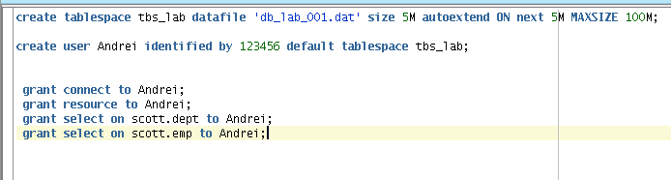

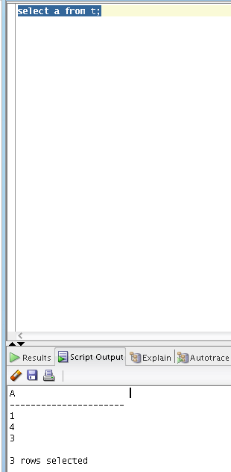

**Task 2 – Understanding Low level of data abstraction: Heap Table Segments**

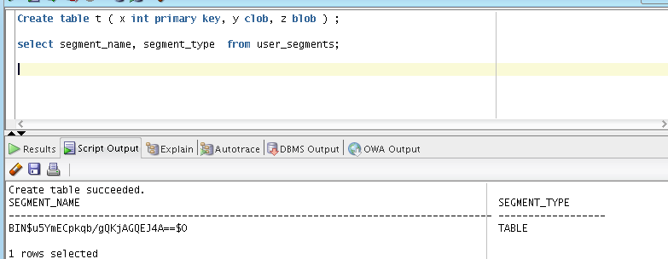

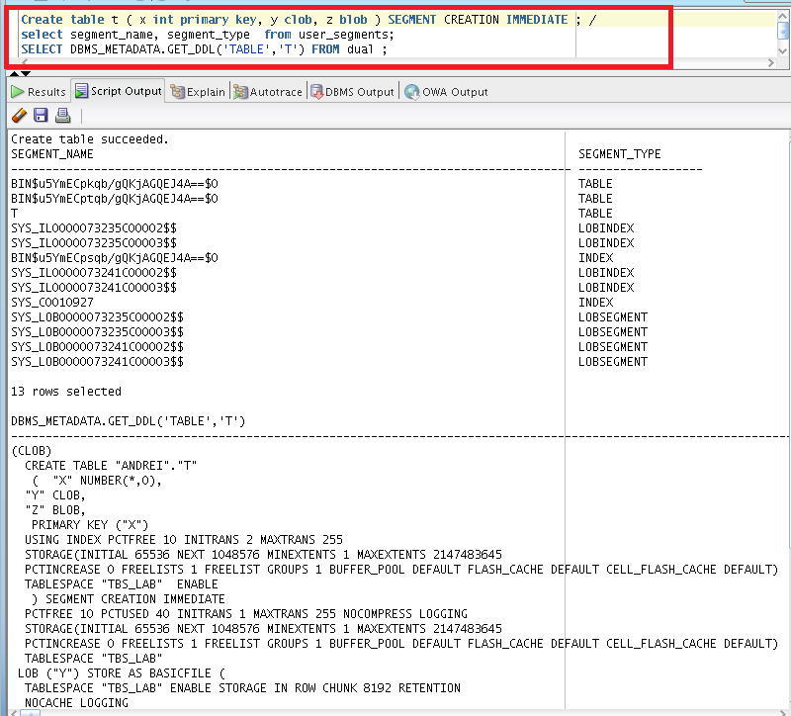

# Index Organized Tables

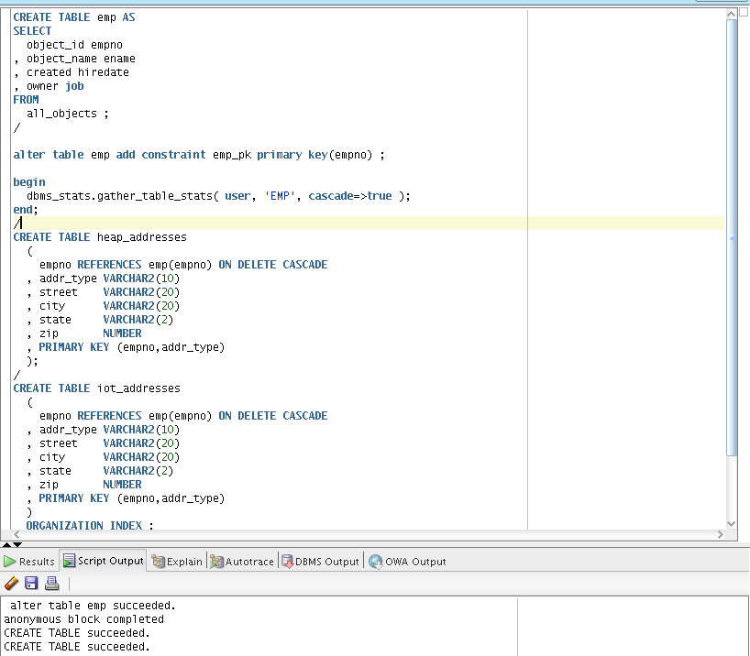

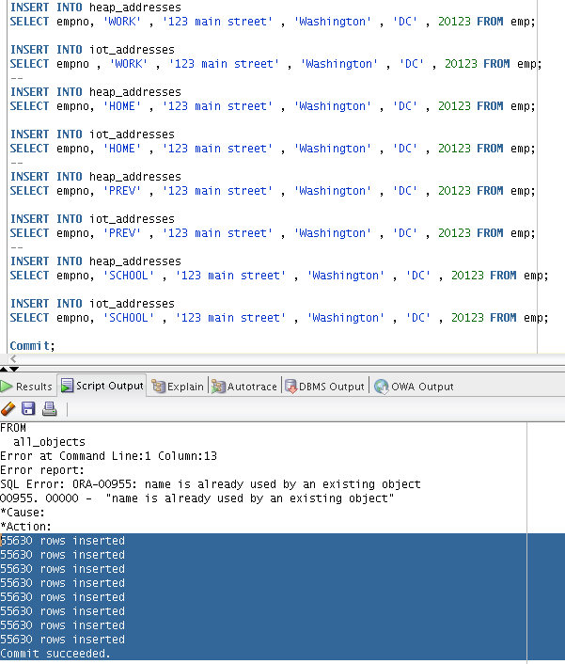

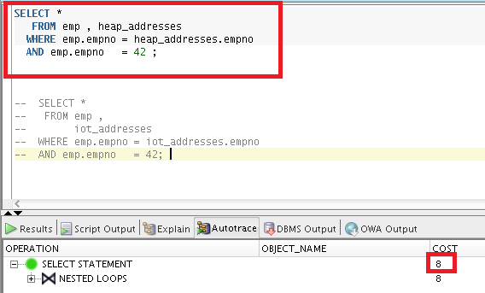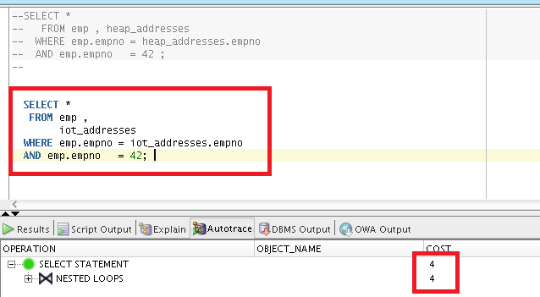

**As we can see, the «cost» is lower, when we use index organized table in query.**

**In Where clause, we used emp.empno field, one time for join and one time to find all rows where emp.empno=42.**

**In heap table we should overlook all rows to read value from empno field. But in IOT using B*tree structured table by empno field, we found directly all rows with required values.**

# Index Clustered Tables

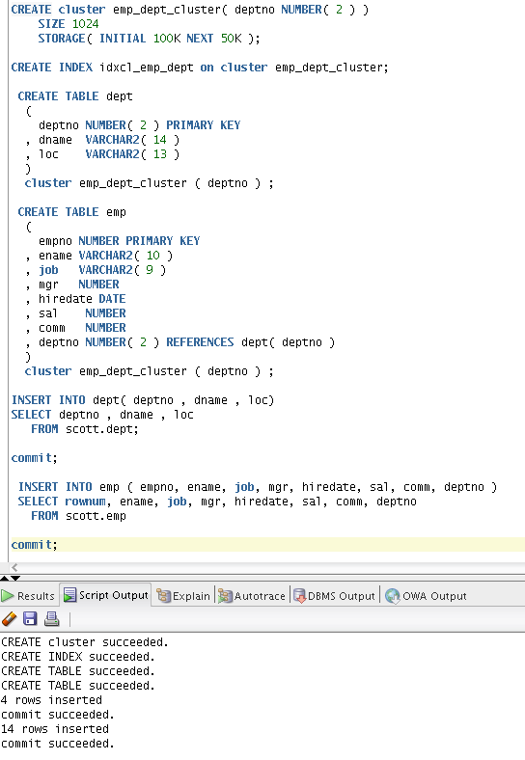

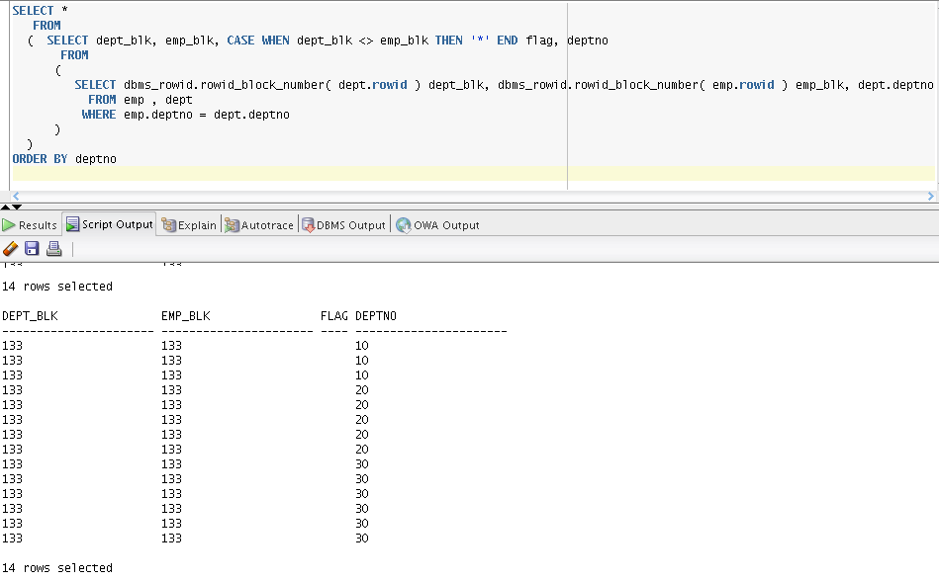

Data from many tables may be stored on the same block. This query show equal number of block where field deptno is storing ☺

# HASH Clustered Tables

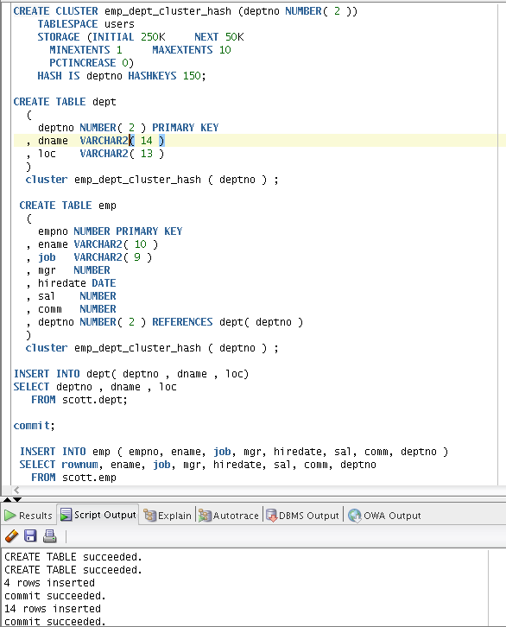

**Hash**

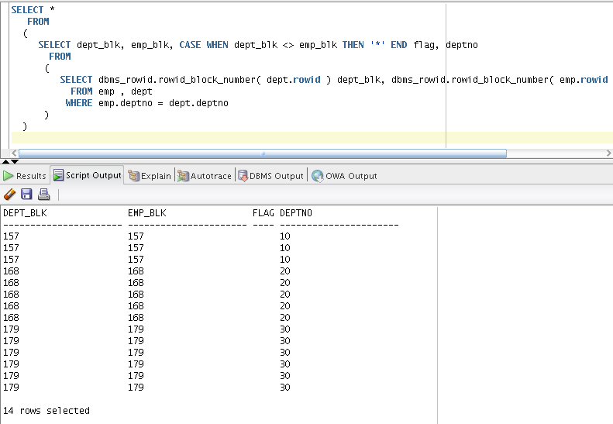

We see ,that equal deptno values still stored on the same block, but now this blocks are not placed together.

Hash cluster

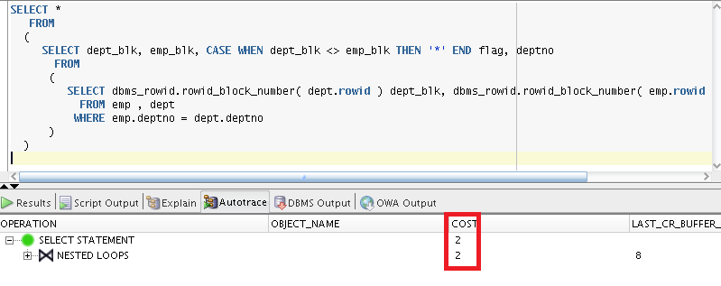

Index cluster

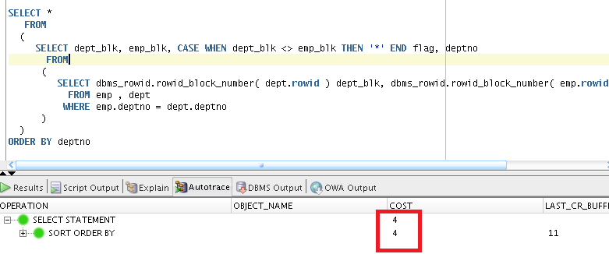

**In Hash clustered table, instead of using a B*Tree index to locate the data, them locate data by hash cluster key. Using hash is more faster way to get data. You can see in on my screenshots.**

